
ZJUI学院2024年暑期科研项目总结材料


中文论文题目 ： 基于第一性原理的铁电材料仿真研究

英文论文题目： The Emulation of Ferroelectric Materials Based on First Principle.

成员姓名：高雨聪
指导教师： 赵亮
指导教师所在学院： 信息与电子工程学院

暑期研究起止日期：2024年6月10日-2024年7月31日

Introduction
Ferroelectric (FE) materials display very peculiar structural, electrical, and electromechanical features. Nowadays, many properties can be accurately computed and predicted from first principles for a given FE material. Even more important, the work of the last decade has revolutionized our qualitative view of the phenomenon of ferroelectricity at large. There are major advances concerning structural and lattice-dynamical properties, spontaneous and induced polarization, dielectric and piezoelectric properties, and structural phase transitions at finite temperature. Special attention is devoted to illustrating the novel methods which made such advances possible. So in this report, I want to focus on what I have done so far during the summer research and, since the work is still unfinished, I will also focus on what I will be doing in the next few months.
Contents
Basically, the report will follow the procedures listed below:
Part1: before the experiment: introduction to VASP and use Al2O3 as one example to introduce some parameters
Part2: Tests about Dos Energy band, structural analyses and electronical structure analyses
Part3: conclusion and some future work

Part 1:
  - Introduction to VASP
VASP, short for Vienna Ab initio Simulation Package is a tool used for computing atomic-scale materials modeling, particularly for electronic structure calculations and quantum-mechanical molecular dynamics simulations. It is widely employed in materials science, condensed matter physics, and computational chemistry research. The thing that makes life easier about VASP is its calculation is based on First Principle and Density Functional Theory, so it only requires atomic numbers and fundamental equations of quantum mechanics as inputs. There are four inputs files that users need to create: INCAR, POSCAR, POTCAR and KPOINTS. So from now on, I will use Al2O3 as an example to analyze these four input files.
  - Four Input Files
(I use WinSCP as displayer)
1.2.1 INCAR
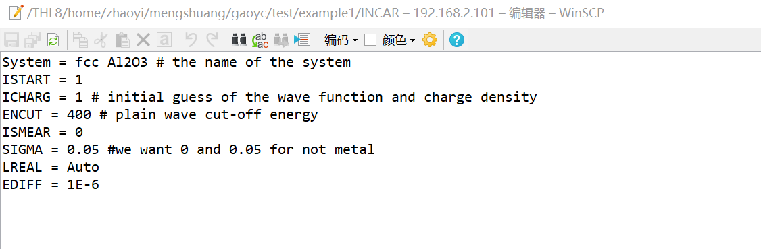
This is the file relating to basic requirements that users want to implement. Line 1 is the name of the system which can be anything. line 2 and 3 contains the initial guess of the wave function and charge density, ISTART is 1 if WAVECAR(file containing the basic information of the wave function) exists and should be used. ICHARG can be 0,1,2,4,10,11,12 depending on what charge density users want to guess(usually takes 2 at the beginning of the trial). Line 4 contains ENCUT which is the most important parameter of the wave function: the value of it reflects the cut-off energy of the plain wave, which is related to probability function. Line 5 is smear value, which represents the difference between the highest Fermi energy band and the lowest Fermi energy band. We take 0 for Gaussian Smearing in this experiment. Line 6 represents whether this material is a semiconductor or metal or insulator. 0.05 for insulator or semiconductor and 0.2 for metal. The next two lines are depending on actual situation, meaning it can be ignored or added. For example the last line represents the energy difference between different iterations.
1.2.2 POSCAR
It starts with the name in line 1 which is the same situation. Then number 1.0 in line 2 is the scaling parameter, depending on how large users want the cells to be. Then 3*3 net parameters is the information of the vectors in three directions, if it is greater than 0, then it represents the length of the sides. If it is zero there may have zero length which in other words, a vertical. Direct means this calculation is based on Direct coordination rather than Cartesian or something else. Every line represents a coordinate of the atom inside one cells. Actually, this input file can be fetched from the pseudopotential library, which contains the information of all existing components.
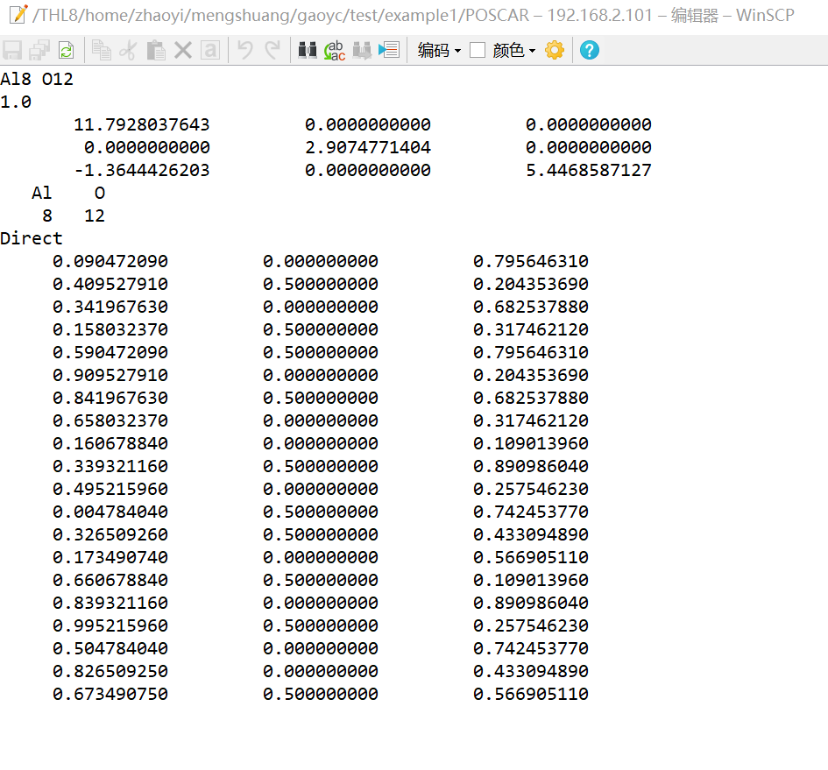
1.2.3 POTCAR
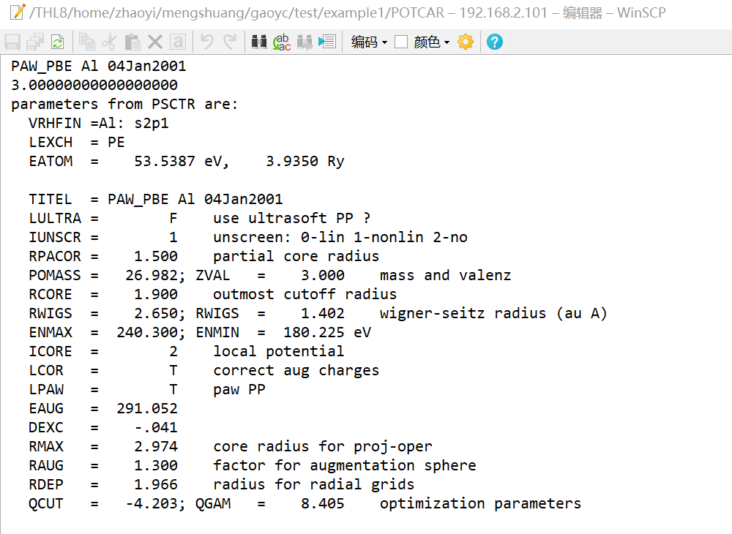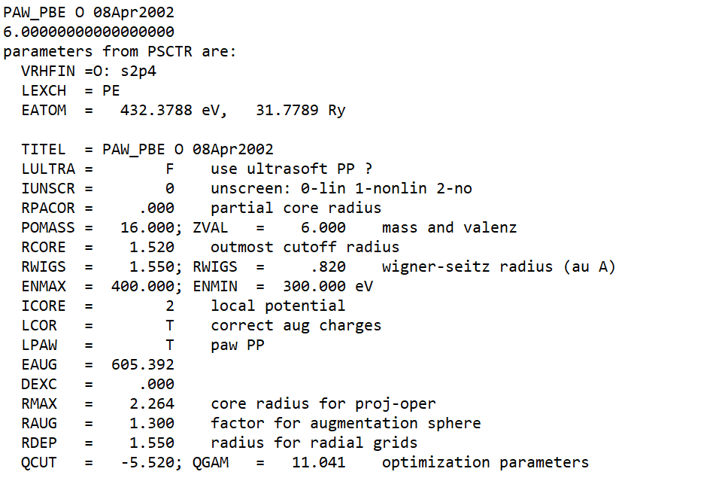

This is only a small part of POTCAR, which is quite a large file. Same as POSCAR, users need to download from pseudopotential library. The POTCAR file contains pseudopotential information for each element. For systems with multiple elements, individual POTCAR files need to be concatenated in the order of elements listed in the POSCAR file. In this example I download both the Al and O and put the two together. This file includes information about the scattering properties of atoms, designed to reproduce atomic properties over a wide energy range. For GW calculations, it's recommended to use POTCAR files with the "_GW" suffix, which are constructed over a larger energy range suitable for calculating many unoccupied states. The header of the POTCAR file contains important information such as the element name, type of exchange-correlation functional, and atomic energy. The POTCAR file determines the type of pseudopotential used in the calculation, such as van der Waals corrections or ultrasoft pseudopotentials. Different types of calculations may require different POTCAR files, such as those for GGA or LDA calculations. The file also includes initial charge density information, which is used in the first few steps of the calculation.
1.2.4 KPOINTS
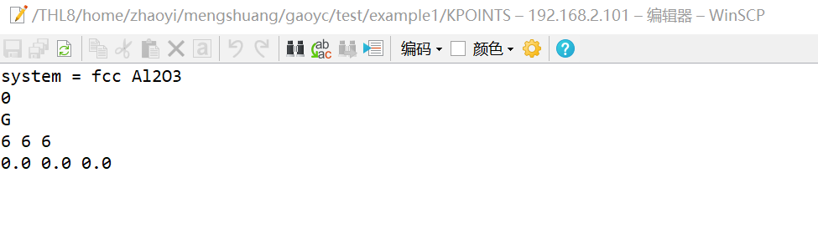
K point means the k point in First Brillouin zone. This is a very simple file including the name on the line 1. 0 stands for grid which is generated by program itself, then G represents Gamma centered M-P grids which is the method the program would use to generate grids. Then 6,6,6 represents the number of k points per grid you want to get in three directions. Then three floating number at the last line is the shift distance of the grid, 0 represents no shift.
  - important Output Files
Basically, there are 3 important Output files that needs to be stressed: OUTCAR, CONTCAR, and OSZICAR.
    - OUTCAR
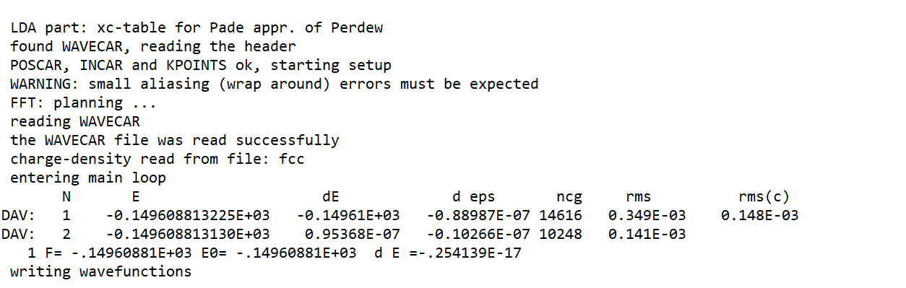
OUTCAR itself is a very large file containing all the messages that VASP calculated. So I only take the STD.OUT file to stress the most important part of the OUTCAR. First few lines are about whether the program successfully operates. Entering the main loop brings the program in calculating the converge energy of the system.(SCF iterations), DAV means the method of the iteration which is the Blocked Davidson Iteration Schema. N is the current step, E is the current energy, dE and deps is the energy difference which should be less than 0.00001 to represent convergence. In this case for Al2O3, it is successfully converged at the second step with the final output F and E0 and dE.
    - CONTCAR
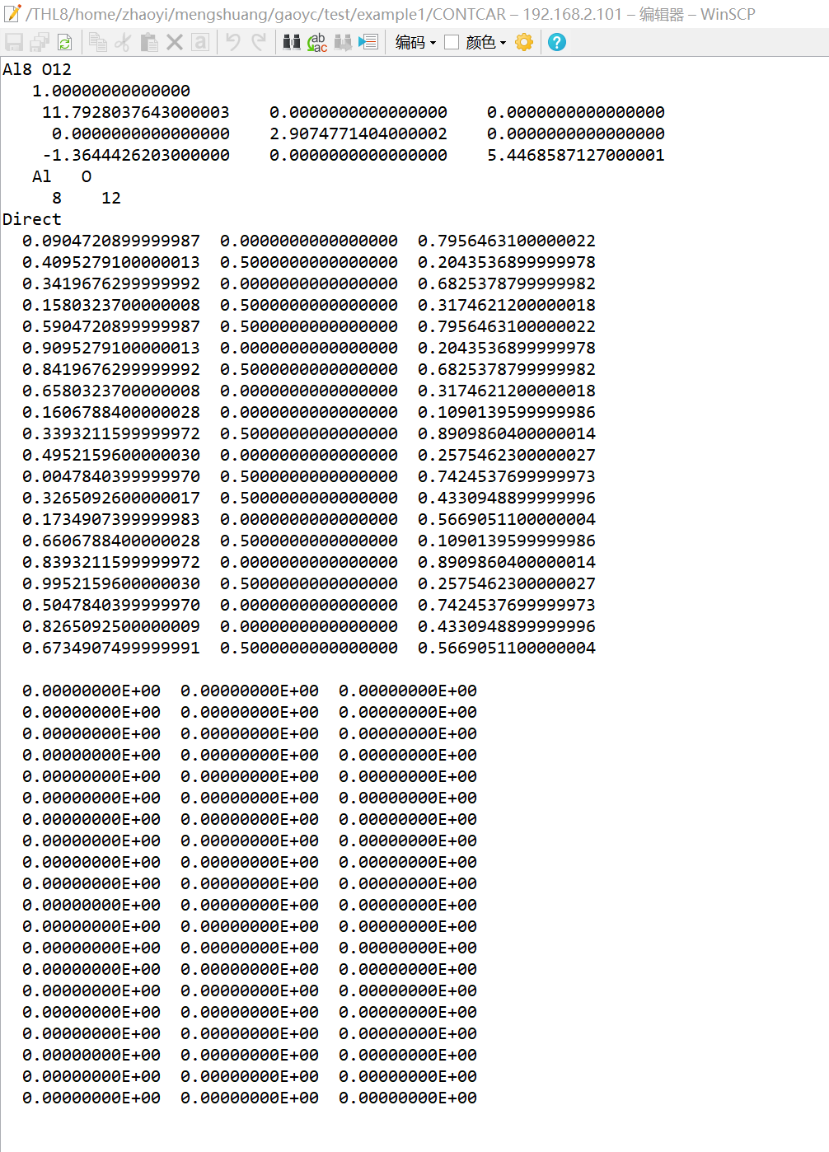
The CONTCAR file typically includes Lattice parameters, Bravais matrix (lattice vectors) , Ionic positions, optionally, ionic velocities (for molecular dynamics simulations). The CONTCAR can be used as a restart file for the next calculation if desired, by copying it to POSCAR. (used for keeping on the iteration). It also might contain additional information about the system, such as ion and lattice velocities. The last several lines of the example are the velocities. Since there is no molecule dynamics calculation involved, the values are all zero. In molecular dynamics simulations, the CONTCAR file will contain the final configuration of the system. It's important to note that CONTCAR files typically contain higher precision coordinates than manually created POSCAR files, which can be crucial for maintaining symmetry in subsequent calculations. For geometry optimization or relaxation calculations, the CONTCAR file will contain the relaxed structure, which may differ from the initial POSCAR structure.
    - OSZICAR
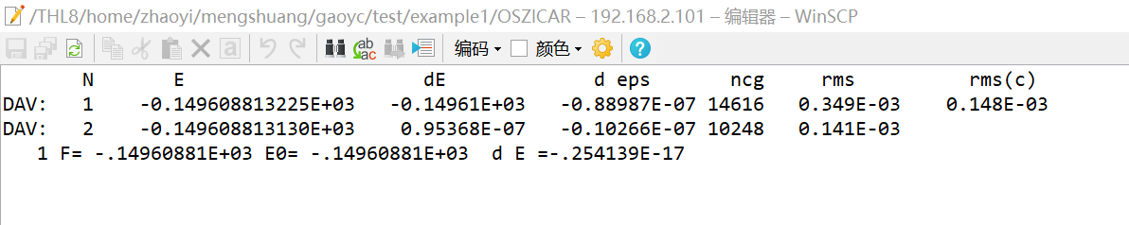
It typically includes Information about the chosen SCF (Self-Consistent Field) algorithm, Convergence data for total energy, charge density, spin density, free energies and magnetic moments of the cell. For each electronic step, it shows Step number, free energy, energy change from the previous step, Charge density and magnetization differences. For calculations involving ionic movements, it shows Ionic step number, free energy, Energy change from the previous ionic step, convergence monitoring(The OSZICAR file is particularly useful for quickly checking if a calculation has converged without having to parse the larger OUTCAR file.). It can help identify issues such as slow convergence or oscillations in the SCF cycle.(Which is mentioned in OUTCAR). While the OUTCAR file provides more detailed information, the OSZICAR file offers a quick overview of the calculation progress and results.

Part2 : Some tests
2.1 convergence test
As mentioned in INCAR file, there requires initial guess about the charge density and the wave function, the method to get a perfect initial guess is to apply convergence test. Still, we use Al2O3 as an example of the test.
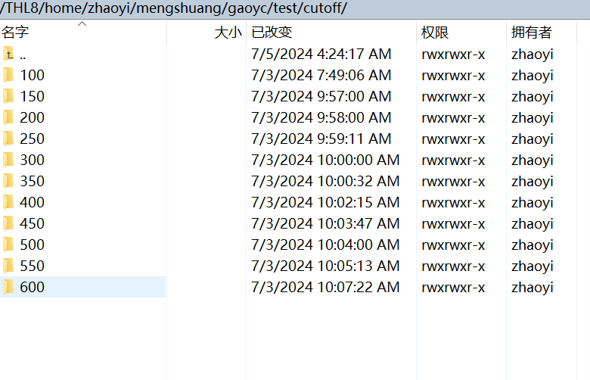
The name of each directory is the value of ENCUT I want to test in different cases. Applying different types and values of basic wave functions, we can get the proper convergence energy.
After using different values and using the same other 3 input files to calculate, we can focus on only the OUTCAR file to determine the energy.(I will only show several cases to clarify)
Test cases for ENCUT = 100,200,300,400,500,600
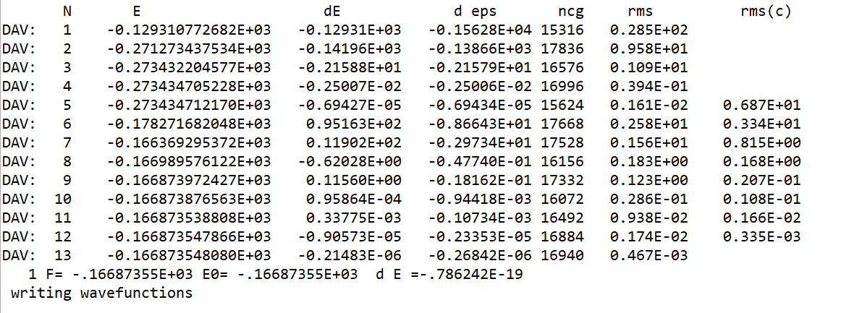
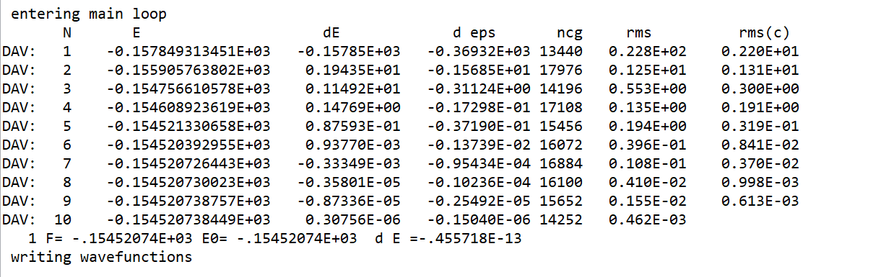
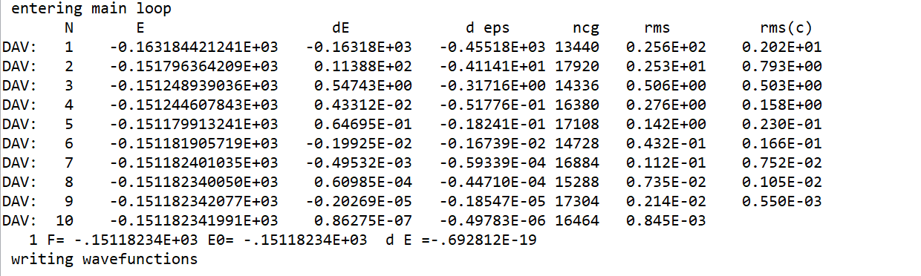
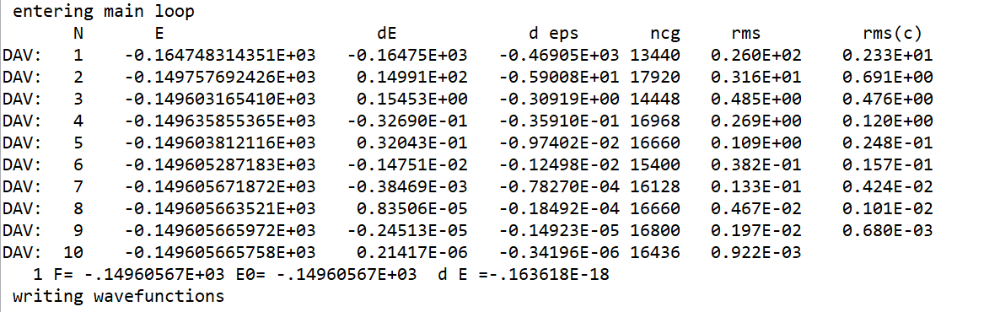
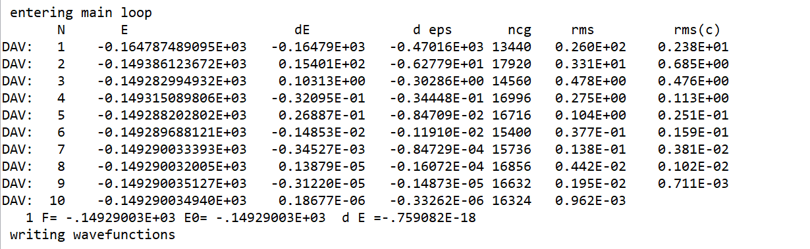
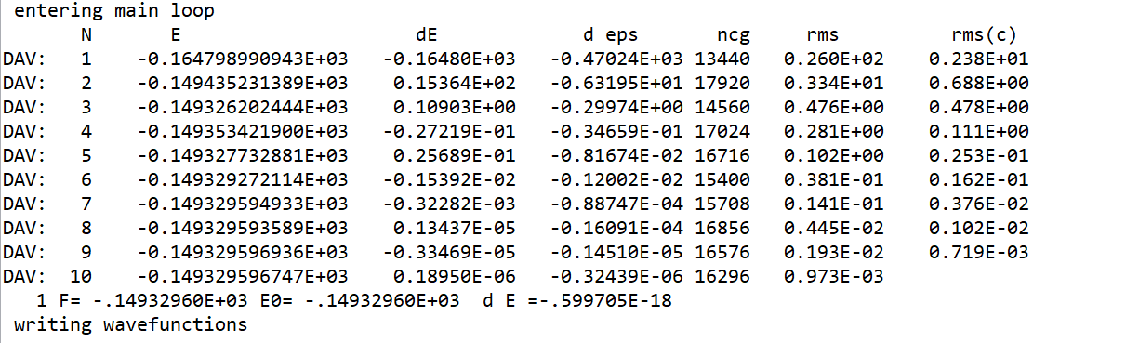
We can see the times of iteration comes to a steady pace after
ENCUT = 200, (the last row entry of the table). So the proper value of the ENCUT would be around 200. If requiring a more specific value, we need to do test between 200 and 300(the result is approximately 240, which matches the suggestion given on the forum).
2.2 Structure Analysis
There is one clue that AlN resembles a lot with AlScN so we can cut in by using the structure analysis of different AlN cells. Like this(hex)
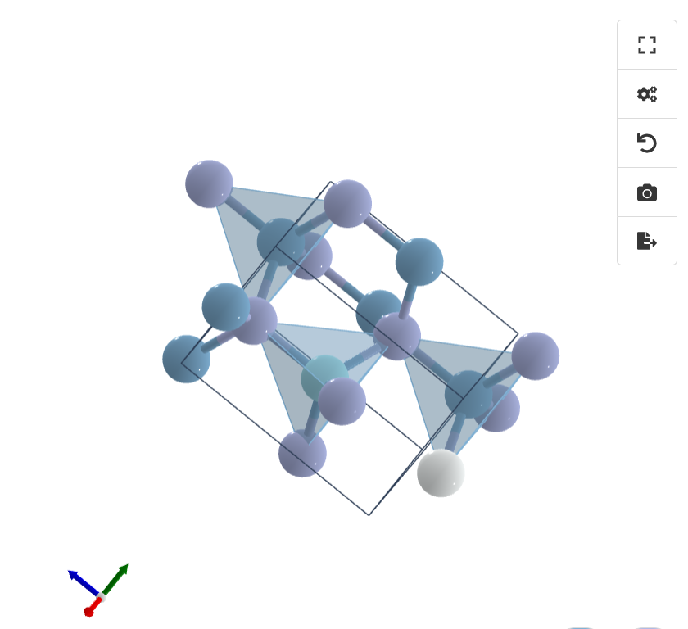

Here is the result of the observation:
1.Band Gap Characteristics : AlN typically exhibits a direct band gap
Band gap width is approximately 6.2 eV (calculated using HSE06 functional)
2.Valence Band Maximum (VBM):Located at the Γ point
Conduction Band Minimum (CBM):Also located at the Γ point, confirming the direct band gap nature
3.Density of States (DOS) Analysis
Total DOS : Valence band top is primarily contributed by N 2p orbitals
Conduction band bottom is mainly composed of Al 3s and 3p orbitals
Projected DOS (PDOS):N atom:2s orbital shows significant contribution in the range of -15 eV to -12 eV
2p orbital dominates at the valence band top (-6 eV to 0 eV)
Al atom:3s and 3p orbitals have notable contributions at the conduction band bottom (above 6 eV)
Fermi Level : Located in the middle of the band gap, approximately at 3.1 eV

Part 3 : for future plans
Unfortunately, the experiment stops due to a long time period, for example every trial run may take up to hours or even days. Currently I want to carry out the research on doing the materials myself like designing a proper structure in vesta and calculate its parameters like cut-off energy and so on. Generally, this experiment fits me well and I learned a lot about solid Physics and Chemistry. I want to express my gratitude to my mentor and one of his students who patiently taught me a lot about this project. So I would continue on this project with my mentor and In the next stage, I will focus more on the actual practice.

